**Illuminated Commodore Logo Rev. 0  
Module description**

The Commodore Logo is a sort of fan art and the purpose is the use in hobby projects. A transparent 3D printed body is illuminated with two LEDs and masked with a face plate, that is designed to the measures defined in a document about the Commodore C= logo.

The PCB contains two 5mm LEDs, which are sufficient to illuminate the logo. These LEDs require a current limiting resistor each, which is also contained on the PCB.

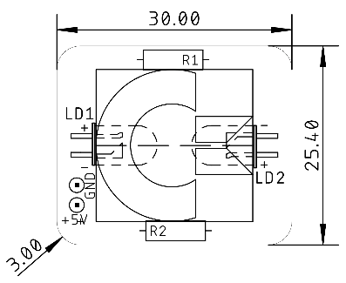

Figure : Dimensions of the PCB

For 5V supply voltage and a standard red, green or yellow LED, a value of 330Ω is sufficient. For other LEDs, like a blue or white LED, or other supply voltages or currents, the resistor value has to be calculated.

$$R_{LED}=\frac{U_{supply}-U_{f, LED}}{I_{f,LED}}$$

RLED: current limiting resistor for the LED  
Usupply: Supply voltage  
Uf,LED: Forward voltage of the LED  
If, LED: Forward current of the LED

The forward voltage and current can be found in the data sheet of the LED. That is the voltage drop over the LED, when it is conducting and the current should be below the maximum rating. A typical value for a standard LED is Uf, LED is 1.8V and for the current If,LED is 10mA. This results in

$$R_{LED}=\frac{5V-1.8V}{0.010A}=320Ω≈330Ω$$

The available resistor value closest to 320Ω is 330Ω. The resistors do not require a very accurate value, so it is no problem to use what is available. A range of ±10% is ok for this purpose.

A blue LED with a forward voltage of 3.2V and a forward current of 20mA will require a forward resistor, that is

$$R_{LED}=\frac{5V-3.2V}{0.020A}=90Ω≈91Ω$$

A 91Ω resistor is sufficient. Notice: The forward voltages of blue LEDs are varying and it is required to look it up for the specific LED. The same applies for white LEDs.